The HTTP Protocol

*Before you start, you should create a document (or a just a piece of paper) where you should write down the Status Code generated by each of the following exercises (You need this for exercise 4-c)*

1) Monitoring HTTP Headers 1

Create a new NetBeans Maven Web-project.

For this exercise, we will just use the default index.html generated by NetBeans.

Press the run button. When you see the file in the browser (Chrome), open the network tab in the developer window (Ctrl-shift-j) and press F5

Observe and explain each of the values monitored (use view source to see the plain messages).

304 – Not Modified

This is used for caching purposes. It tells the client that the response has not been modified, so the client can continue to use the same cached version of the response.

200 – Success

Hints: In order to better observe the values related to Caching you might need to:

Go back to NetBeans and rename your file to index1.html

Go back to your browser and (while the developer window is open) change the url to point to the new file.

Observe the values

Press F5 and observe the values again.

Explain what you see.

First load I just get 200.

Refresh I get 200 and 304. So 304 means that it just loaded from cache. If I want to force a fresh page load, I can do ctrl+enter.

2) Monitoring HTTP Headers 2

Add an image to the page

Add an external style sheet to the page <link rel="stylesheet" type="text/css" href="myStyle.css">

Reload the page again, observe the request(s) being made, and explain the purpose of the connection header.

<https://www.imperva.com/learn/performance/http-keep-alive/> - Explains it so I understand it.

Basically it ensures that the connection stays open for “KeepAliveTimeout” as long as there is free “MaxKeepAliveRequests” slots free. So you don’t have to handshake for each request.

3) Monitoring HTTP Headers 3  (Response-codes 3xx)

In the Web-project, created for 1+2, add a new HTML-page called **r.html** and add this text in an h1-tag “**You got redirected to me**”.

Use the Wizard to create a servlet called redirect

Remove the processRequest and the doPost method completely from the generated servlet-code.

In the doGet(..) method replace the call to processRequest with this line: response.sendRedirect("r.html");

While your server is running, open a (Chrome) browser, and Developer Tools and the network tab.

Enter the address for the servlet (**http:localhost:8080/redirect)** into the browser and explain:

* The two HTTP-request you see
  + 200 – Success (Loaded r.html)
  + 302 – Found - This response code means that the URI of requested resource has been changed temporarily. New changes in the URI might be made in the future. Therefore, this same URI should be used by the client in future requests.
* How the browser knew where to go in the second request
  + In the web.xml we have this mapping: 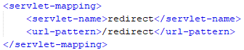
  + That sends us to redirect servlet. 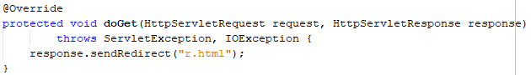
  + That sends back a redirect response to r.html.

3a) Redirecting to HTTPs instead of HTTP

In Chrome enter this address (with the developer window + the network-tab open), and exactly as it is spelt: [**http://studypoints.info**](http://studypoints.info)

Explain the first two request monitored (notice where you requested to go, and where you actually ended).

I requested <http://studypoints.info>.

That has been moved permanently (301) and so we get a redirect response to <https://studypoints.info>.

Important: Later this week, you will learn how to set up your own server to use https, and ONLY https.

4a) Status Codes (5xx)

Use the Wizard to create a servlet called **Ups**

In the processRequest(..) method,  just before the try-statement add this code:

int result = 100/0;

While your server is running, open Chrome developer tools and the network tab and then call the servlet.

Write down the response code generated by the server as for the previous exercises

500 :

java.lang.ArithmeticException: / by zero

# HTTP Status 500 – Internal Server Error

4b) Status Codes (4xx)

While your server is running, open Chrome developer tools and the network tab, and call this address: **http://localhost:8080/i_dont_exist**

Write down the response code generated by the server as for the previous exercises

**HTTP Status 404 – Not Found**

4c) Status Codes – Ranges

List of codes:

* 404 – Not found
* 500 – Internal Server Error
* 301 – Moved Permanently
* 200 – Success
* 302 – Found (Temporarily Moved Resource)
* 304 – Not modified (Loaded from cache)

Your document, containing the Status Codes for all the exercises done so far, should now contain codes like 2xx, 3xx, 4xx and 5xx.

Explain (write down your answer so you won’t forget) the meaning of the first digit in the 3-digit Status Codes you have seen so far.

5) Get HTTP Request Headers on the Server

We have seen that an HTTP request from a Browser typically includes a lot of headers with information related to the client.

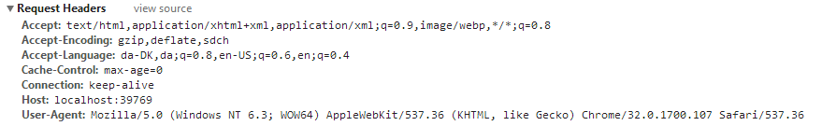

This information is available to a servlet (actually to any web-server technology)  via the request object. Create a Servlet, which should output this information in a table as sketched in this figure (or in any way you like, but don’t focus on presentation).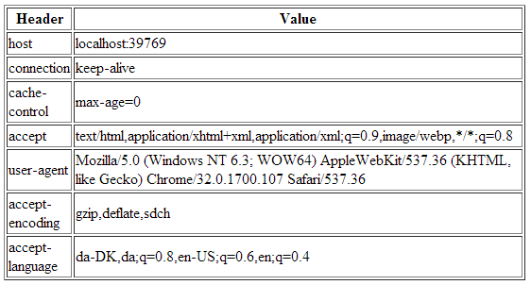

*Hints: Use the request objects getHeaderXXX methods.*

6) Get/Post-parameters

Create a new HTML-file in the web-project made in exercise 1.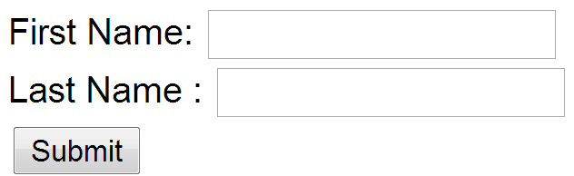

Add a form to the file, including two text input boxes and a submit button as sketched below:

Add an extra input field to the form with type=”hidden”, name=”hidden” and value=12345678.

Add the value “#” for the forms action attribute.

Set the forms method-attribute to the value “GET” (actually the default value) and test the form. Observe what happens in your browser's address field.

I get ?hidden=12345678 at the end of the URL, but otherwise returned to the same page



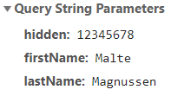

Change the forms method-attribute to the value “POST” and test the form. Observe the change in your browsers address field. Figure out (using Chrome Developer Tools), how parameters are passed in, for a POST request.

Now there is not the ?hidden=12345678

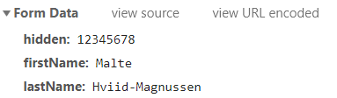

Now it is part of the header instead of the url.

Write down your observations

Session and Cookies

*For the next two exercises/demos you should create a new Maven web-project. Both the demos use a Servlet.*

7)      Sessions (Session Cookies)

In your web project use the wizard to generate a  new Servlet

1. Enter ***SessionDemo*** as the name of the Servlet and *servlets* as package name
2. Right-click the file and select Run to see “what is does”
3. Change the generated processRequest(..) method as sketched below.

protected void processRequest**(**HttpServletRequest request**,**

                              HttpServletResponse response**)**

**throws** ServletException**,** IOException **{**

    String name **=** request**.**getParameter**(**"name"**);**

**if** **(**name **!=** **null)** **{**

      request**.**getSession**().**setAttribute**(**"name"**,** name**);**

**}** **else** **{**

      name **=** **(**String**)** request**.**getSession**().**getAttribute**(**"name"**);**

**}**

    response**.**setContentType**(**"text/html;charset=UTF-8"**);**

**try** **(**PrintWriter out **=** response**.**getWriter**())** **{**

      out**.**println**(**"<!DOCTYPE html>"**);**

      out**.**println**(**"<html>"**);**

      out**.**println**(**"<head>"**);**

      out**.**println**(**"<title>Servlet SessionDemo</title>"**);**

      out**.**println**(**"</head>"**);**

      out**.**println**(**"<body>"**);**

**if** **(**name **!=** **null)** **{**

        name **=** **(**String**)**request**.**getSession**().**getAttribute**(**"name"**);**

        out**.**println**(**"<p> Welcome " **+** name  **+** " !</p>"**);**

**}** **else** **{**

        out**.**println**(**"<h2>Please enter your name, and submit</h2>"**);**

        out**.**println**(**"<form action='SessionDemo'>"**);**

        out**.**println**(**"<input type='input' name='name'>"**);**

        out**.**println**(**"<input type='submit'></form>"**);**

**}**

      out**.**println**(**"</body>"**);**

      out**.**println**(**"</html>"**);**

**}**

**}**

1. Enter your name and press submit, copy the URL in the browser into your clipboard, close the tab (but not the browser) and load the page again in a new tab using the URL in the clipboard.
2. While doing the things in step d, you should monitor the content of your local cookies and the HTTP requests being sent, using the development tools in Chrome.
3. **Most import part of this exercise:**

Explain using both words and images how the Server can maintain state between subsequent calls even when the state is not transmitted from the client to server.

If I have entered my name, then it stays at “Welcome Malte !” until I clear site data. Which means the data is saved in the session. If I wait 30 minutes, it should be cleared.

The server knows the state. The Client just sends along the and then the server knows the data that belongs to that ID. We used this a lot for the 2nd Semester Exam project. To keep people logged in, etc. It uses the modern web storage API (sessionStorage)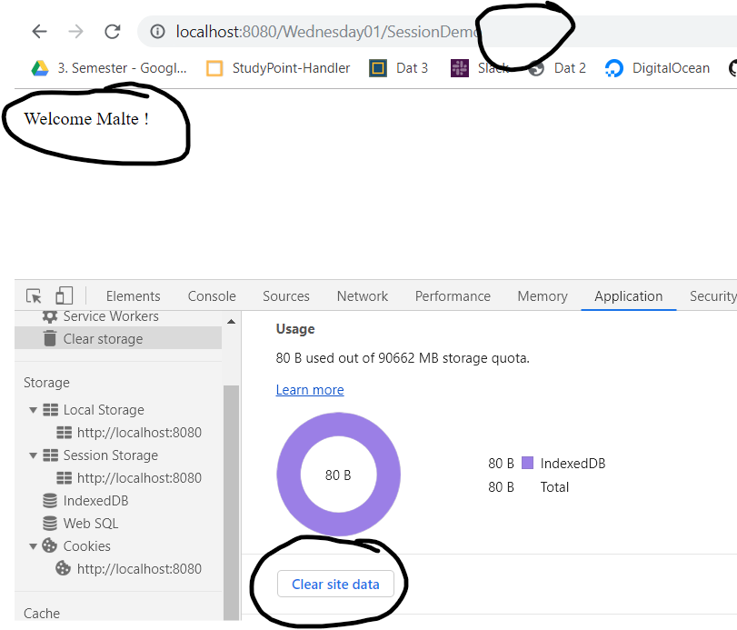

Great explanation of Cookies: <https://developers.google.com/web/tools/chrome-devtools/storage/cookies?utm_source=devtools>

Write down your observations

8)     Persistent Cookies

1. In your web project, use the wizard to generate a new servlet
2. Enter *CookieDemo* as the name of the Servlet and *servlets* as package name
3. Change the generated processRequest(..) method as sketched below.

protected void processRequest**(**HttpServletRequest request**,** HttpServletResponse response**)**

**throws** ServletException**,** IOException **{**

String name **=** request**.**getParameter**(**"name"**);**

**if** **(**name **!=** **null)** **{**

Cookie cookie **=** **new** Cookie**(**"username"**,** name**);**

cookie**.**setMaxAge**(**60 **\*** 60 **\*** 24 **\*** 365**);**

response**.**addCookie**(**cookie**);**

**}**

Cookie**[]** cookies **=** request**.**getCookies**();**

**if** **(**cookies **!=** **null)** **{**

**for** **(**Cookie cookie **:** request**.**getCookies**())** **{**

**if** **(**cookie**.**getName**().**equals**(**"username"**))** **{**

name **=** cookie**.**getValue**();**

**}**

**}**

**}**

response**.**setContentType**(**"text/html;charset=UTF-8"**);**

**try** **(**PrintWriter out **=** response**.**getWriter**())** **{**

/* TODO output your page here. You may use following sample code. */

out**.**println**(**"<!DOCTYPE html>"**);**

out**.**println**(**"<html>"**);**

out**.**println**(**"<head>"**);**

out**.**println**(**"<title>Servlet CookieDemo</title>"**);**

out**.**println**(**"</head>"**);**

out**.**println**(**"<body>"**);**

**if** **(**name **!=** **null)** **{**

out**.**println**(**"<p> Welcome " **+** name **+** " !</p>"**);**

**}** **else** **{**

out**.**println**(**"<h2>Please enter your name, and submit</h2>"**);**

out**.**println**(**"<form action='CookieDemo'>"**);**

out**.**println**(**"<input type='input' name='name'>"**);**

out**.**println**(**"<input type='submit'></form>"**);**

**}**

out**.**println**(**"</body>"**);**

out**.**println**(**"</html>"**);**

**}**

**}**

1. Enter your name and press submit, copy the URL in the browser into your clipboard, close the tab (but not the browser) and load the page again in a new tab using the URL in the clipboard.
2. Now close your browser (you could even close your laptop, but don’t ;-) , open it again and load the page again using the URL in the clipboard
3. While doing the things in step e, you should monitor the content of your local cookies and the HTTP requests being sent, using the development tools in Chrome.
4. **The most import part of this exercise:**

Explain (on paper) how Cookies can be used to maintain “state” on the client between subsequent calls to a server, even when a browser has been closed down.

Write down your observations